New features in NMRPredict
Version 5.1

Proton Prediction

Drilling down in proton user databases

It is now possible to "drill down" into some proton databases. This means that after a prediction it may be possible to inspect the molecules behind the prediction.

Making user proton databases "drillable"

All new proton user databases you build will automatically be drillable. All proton user databases built in a previous version of NMRPredict can be upgraded by running a small program supplied as part of the installation.

In the example below you can see drilling down into a user database with the minimum amount of information in the database - database letter, solvent and record number (Q, DMSO and 1 in this case)

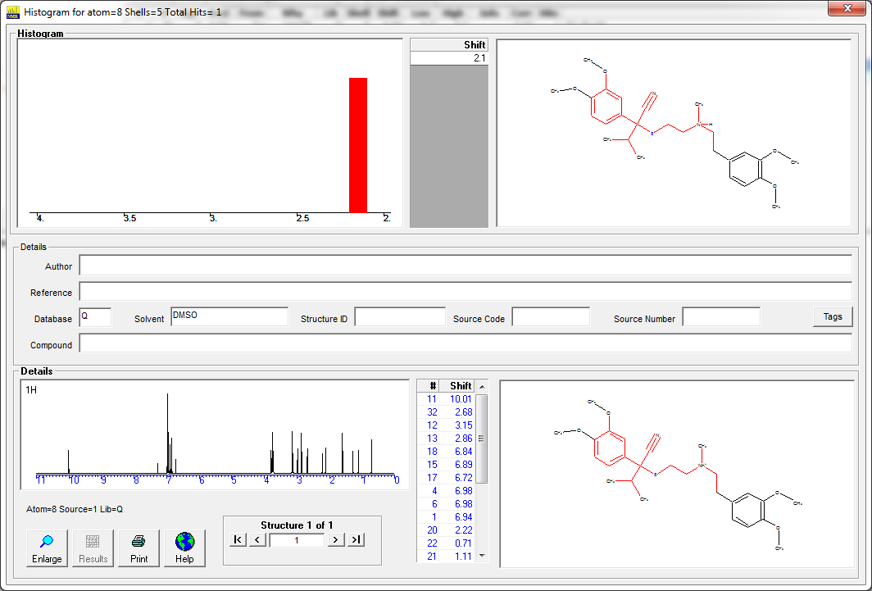

Drillable proton database included

A database initially containing over 2,000 records will be included with NMRPredict. This includes data abstracted from recent literature and should make a significant improvement to proton prediction thanks to its new and relevant data.

The data has been manually reviewed by Professor Ernö Pretsch.

A release of at least 3,000 further data will be made later in 2015.

The screen below shows the sort of information found in the newly supplied database. It includes Compound name, literature reference, author and solvent.

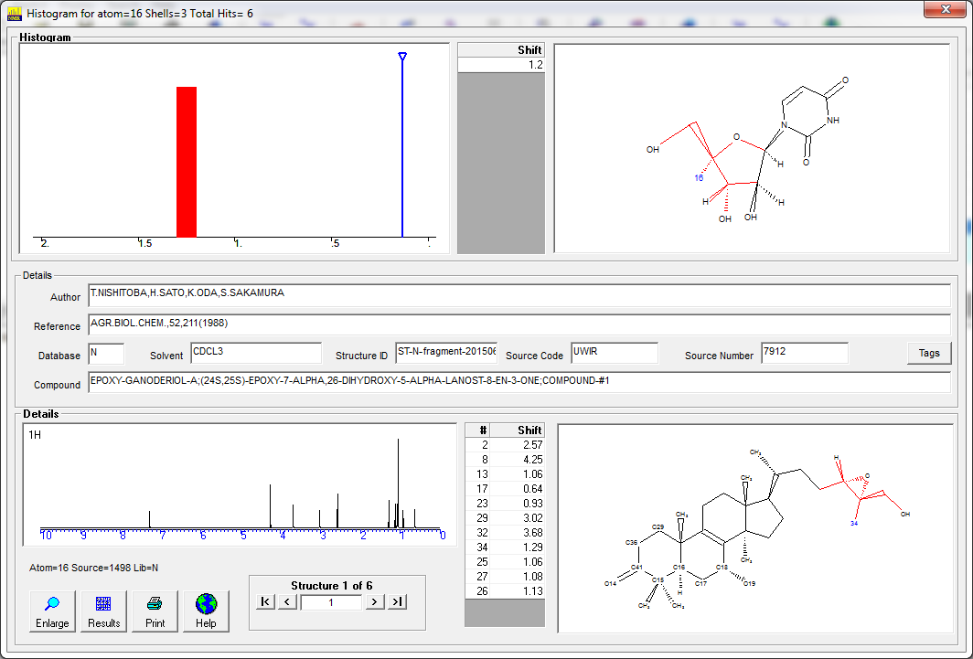

Prediction range not just prediction value

For over 30 years prediction programs have generally provided a simple value for a prediction. In fact any prediction is a best estimate. No prediction is guaranteed to be 100% accurate. In fact a prediction "range" can be far more useful.

Our range means "we are 95% confident that the true value will fall within this range". Note that the range is not per molecule. It is per atom. Some atoms can be predicted with much more confidence than others.

In the example below atom 12 is predicted with a high degree of confidence. The predicted value is 7.32 and the prediction range is 7.1 to 7.6 (a range of 0.5ppm).

Atom 5 is predicted with much less confidence. The predicted value is 3.59 but the range is 2.7 to 4.5 (a range of 1.8ppm).

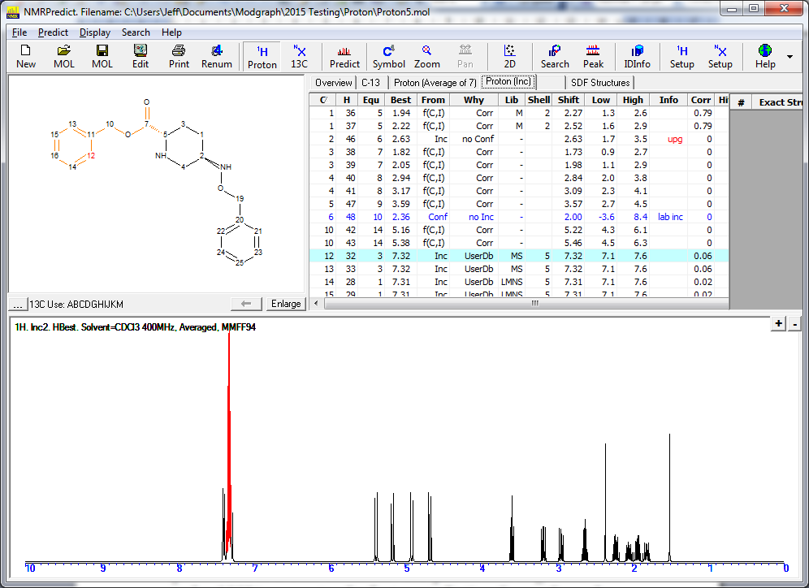

The range can be viewed both in the table view and on the enlarged structure (see below).
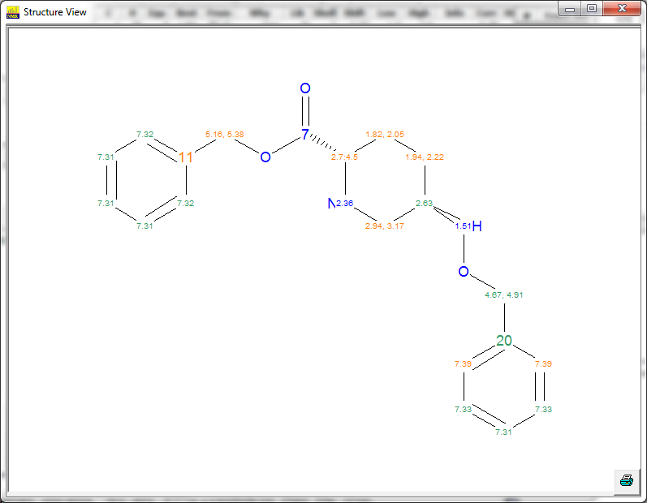

Improved diastereotopic recognition

Molecules which previously were not able to pick up distereotopic protons can now do so.

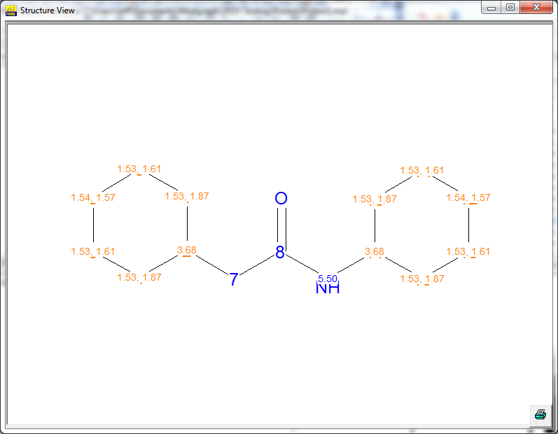

New version of the CHARGE program

We have included a new version of the CHARGE program from Professor Abraham. This has fixed some issues in his conformer approach.

New version of GMMX

We have included a new version of the GMMX program from Dr Gilbert for calculating 3D conformers. This is more stable than previous versions.

Cleaned internal database

The internal proton databases provided with the program have been cleaned with several molecules re-assigned .

Carbon prediction

New data

We have added an additional 10,329 carbon and 1,425 x-nuclei data. All data has been abstracted by Professor Robien and his team.

Corrected data

Professor Robien and his team have corrected over 17,000 records since the last release of the database. These included minor corrections, such a spelling mistakes to major corrections such as mis-assignments.

Prediction range not just prediction value

For over 30 years prediction programs have generally provided a simple value for a prediction. In fact any prediction is a best estimate. No prediction is guaranteed to be 100% accurate. In fact a prediction "range" can be far more useful.

Our range means "we are 95% confident that the true value will fall within this range". Note that the range is not per molecule. It is per atom. Some atoms can be predicted with much more confidence than others.

In the example below atom 17 is predicted with a high degree of confidence. The predicted value is 28.2 and the prediction range is 25 to 32 (a range of 7ppm).

Atom 19 is predicted with much less confidence. The predicted value is 160.9 but the range is 151 to 171 (a range of 20ppm).

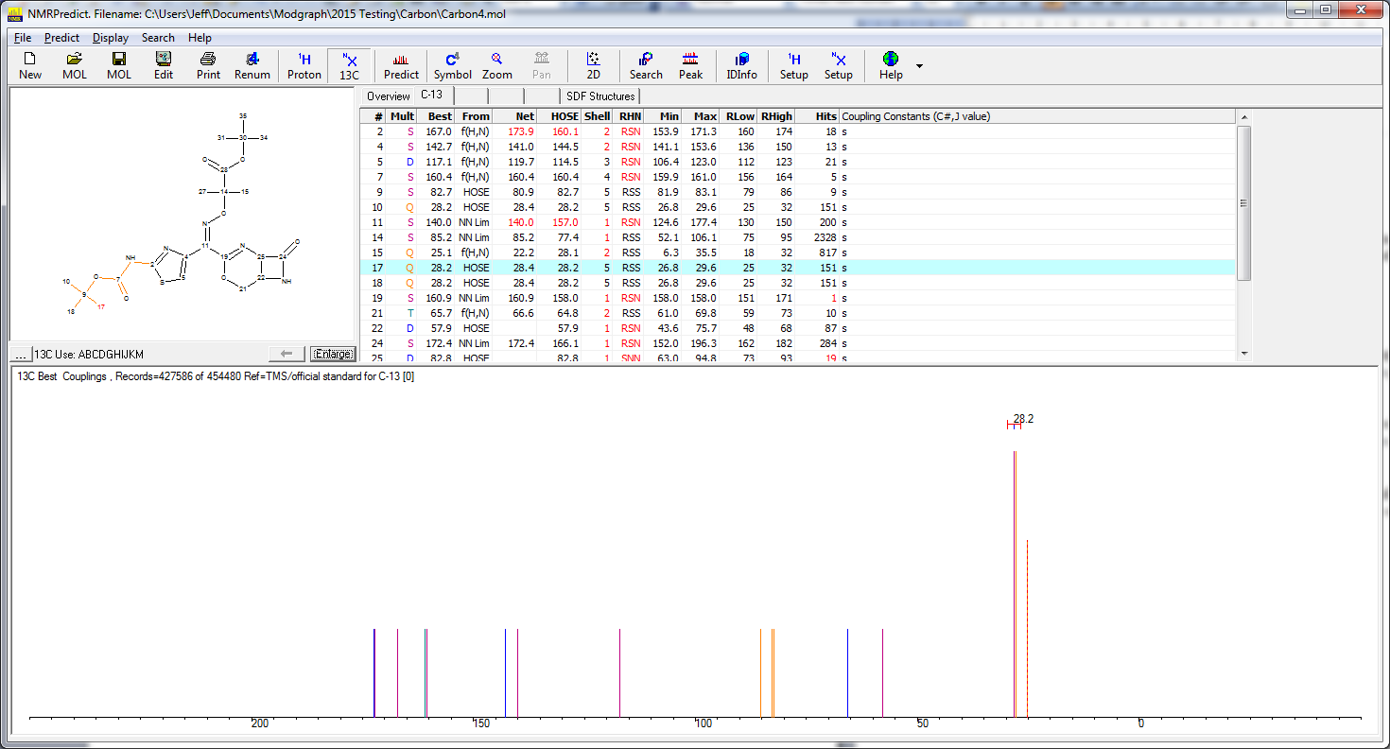

The range can be viewed both in the table view and on the enlarged structure (see below).

